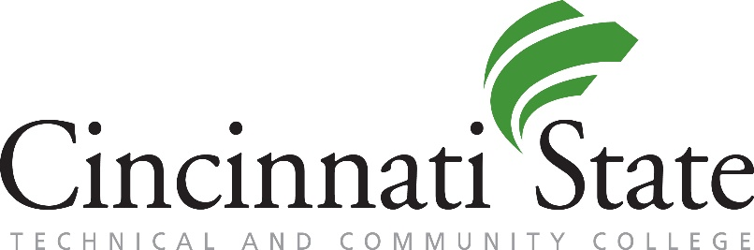
Substance Abuse Treatment

24/7 Crisis Lines:
- Recovery Health Access Center: 513-281-7422 (RHAC)

- Substance Abuse / Mental Health Services Administration (SAMHSA):
1-800-662-HELP (4357)

Services
Addiction Services Council / Recovery Health Access Center
Phone: 513-281-7422 (RHAC)
Website: addictionservicescouncil.org

Substance Abuse and Mental Health Services Administration
Website: https://www.samhsa.gov
Treatment Finder: addictionservicescouncil.org

Center for Addiction Treatment
Phone: 513-381-6672
Website: catsober.org

