Rent, Utility, and Housing Resources
Strategies to End Homelessness
If experiencing homelessness or are at risk of becoming homeless:
- Central Access Point: (513) 381-SAFE (7233)

Community Action Agency
For assistance with rent, utilities, potential eviction, call:
- Hamilton County: (513) 569-1840
- Butler County: Hamilton (513) 868-9300 / Middletown (888) 432-7022

Salvation Army of Greater Cincinnati - Family Services Bureau
Rent, Utility, and Housing Assistance
- Phone: (513) 762-5660
- Main address: 114 E Central Pkwy, Cincinnati, OH 45202

Metropolitan Housing Authority
For access to affordable housing call this number:
- Hamilton County: (513) 721-4580
- Butler County: (513) 896-4411

Housing & Urban Development (HUD)
For access to affordable housing call this number:
- (513) 684-3451

Internet Sites to Connect with Housing Related Resources:
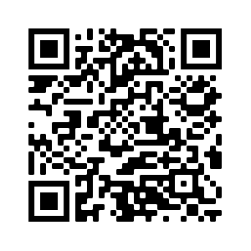
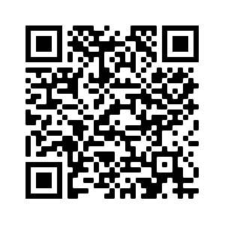
United Resource Connection Site
Consumer Finance Protection Site

