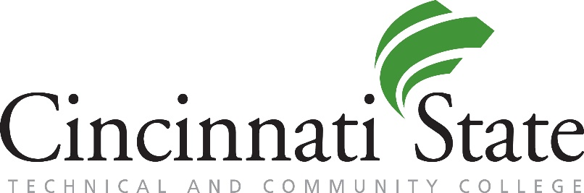
Substance Abuse Treatment
24/7 Crisis Lines:
Recovery Health Access Center: 513-281-7422 (RHAC)
Substance Abuse / Mental Health Services Administration (SAMHSA):
1-800-662-HELP (4357)
Services, Websites, Treatment Locators:
Addiction Services Council / Recovery Health Access Center
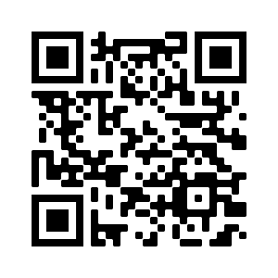
Phone: 513-281-7422 (RHAC)
Website: addictionservicescouncil.org

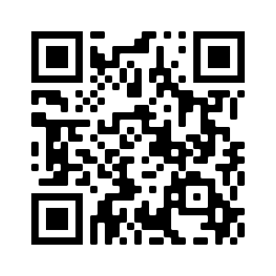
Substance Abuse and Mental Health Services Administration
Website: www.samhsa.gov
Treatment Finder: findtreatment.samhsa.gov

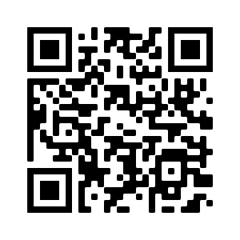
Center for Addiction Treatment
Phone: 513-381-6672
Website: catsober.org

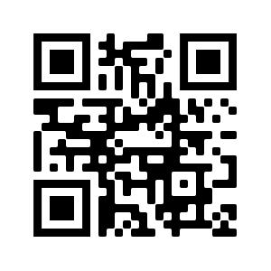
Rehab Spot
Website: rehabspot.com

