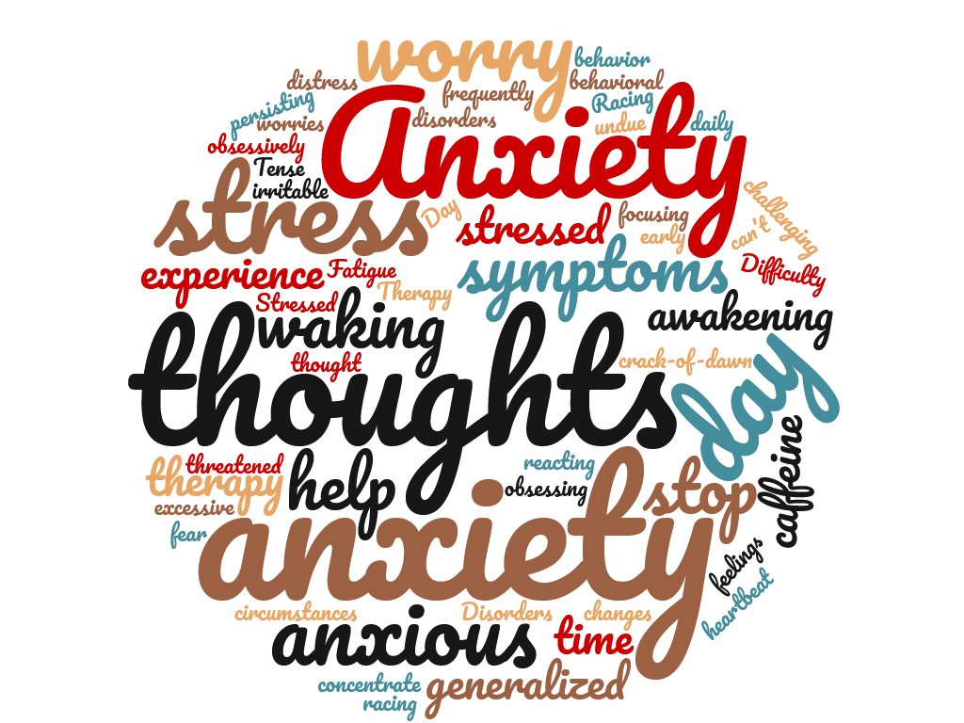
Anxious?
Stressed? Overwhelmed?
Find help together!

ANXIETY SUPPORT GROUP
Now offered free on Cincinnati State’s Campus
The anxiety support group is a self-help group for persons who are experiencing stress, anxiety and other related disorders. Our mission is to help each other in our recovery from anxiety. The group provides peer support, education, sharing and practices recovery techniques to help each other achieve peace of mind. It is open to students and members of the community.

MEETING DETAILS:
Every Wednesday • 6-7:30 PM
Cincinnati State College Clifton Campus • ATLC Building Room 309
If interested in joining virtually please see contact information below

Contact:
Matt Muir • Mental Health America of NKY & SWOH
mmuir@mhankyswoh.org • 859-431-1077 Ext 125

Sponsored by The Wellness Works Alliance

