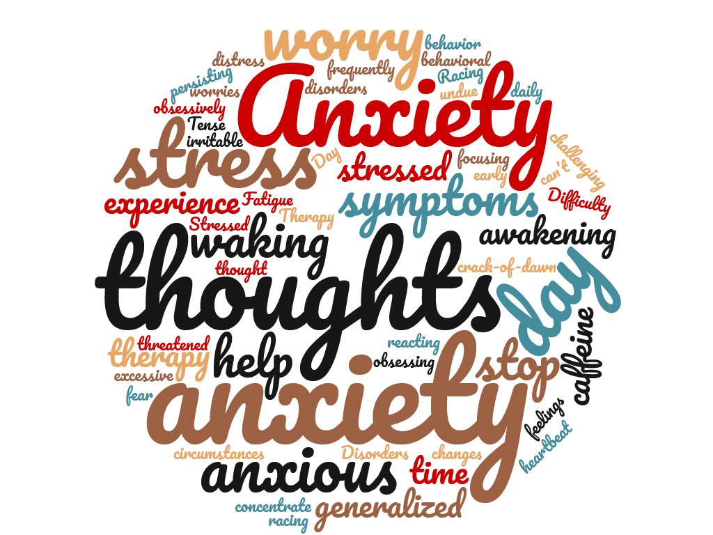
Anxious?
Stressed? Overwhelmed?
Find help together!

ANXIETY SUPPORT GROUP
Now offered free on Cincinnati State’s Campus
The anxiety support group is a self-help group for persons who are experiencing stress, anxiety and other related disorders. Our mission is to help each other in our recovery from anxiety. The group provides peer support, education, sharing and practices recovery techniques to help each other achieve peace of mind. It is open to students and members of the community.

MEETING DETAILS:
We Apologize for the inconvenience, but this group is currently on hold. It will resume in the future. Please check back or contact the Counseling Center for updates.

Contact:
Counseling Center
(513) 569-5779
counseling@cincinnatistate.edu

Sponsored by The Wellness Works Alliance

